**LAB 12 – PHP**

|  |
| --- |
| At the end of this lab, students should be able to:   * Write simple PHP codes and execute them on the server. * Create a database with tables and attributes using phpmyadmin. * Write PHP codes to perform CRUD (Create, Read, Update and Delete) operations on multiple tables. |

**Guides**

1. **Create the Database, Tables and Attributes.**

* Open <http://localhost/phpmyadmin>
* Create a database called **chocolate.**
* Import a database from folder Lab 12 called **chocolate**.
* Now suppose you have 2 tables called **product** and **purchase**. The attributes for each of the tables as shown below.

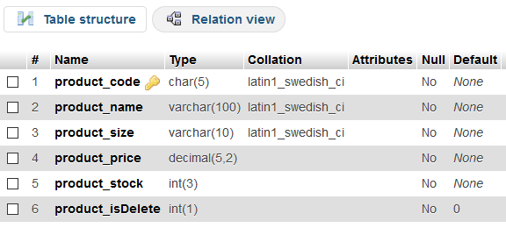

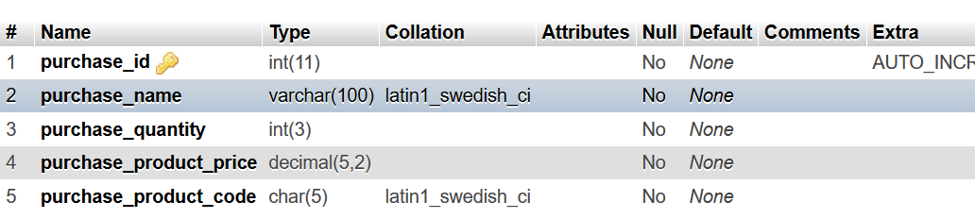

1. **Create the PHP web pages.**

* Go to **C:\** drive. Double click on **XAMPP**. Double click on **htdocs**. In this **htdocs** folder create another folder called **Lab12**.
* All the files for this lab must be saved into this Lab12 folder.
* Run each of your lab questions as shown below:
  + Open any browser.
  + Type at the URL: [http://localhost/Lab12/<filename.php>](http://localhost/Lab12/%3cfilename.php%3e). Please DO NOT double click on the php file to execute it.

1. **Add New Product**

* Open the **add_product.php** file in Notepad++.
* Write the PHP codes to insert a new product record.
* Make sure to check the product code is not duplicated in the table. If the same product code is entered more than once, a JavaScript error message must be displayed.
* After a record is successfully inserted into the table, display a JavaScript alert as shown below.

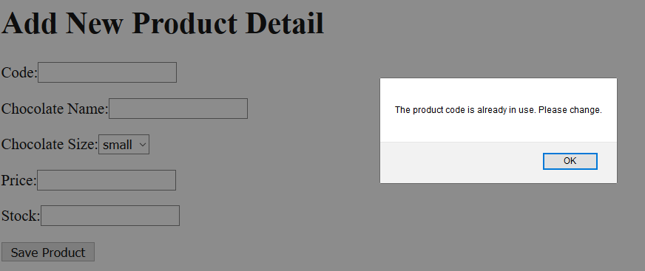

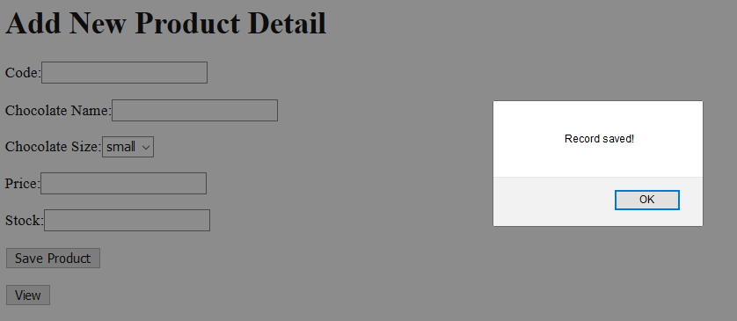

1. **View Product List**

* Open the **product_list.php** file in Notepad++.
* Write the PHP codes to display all the records from the product table as shown below.

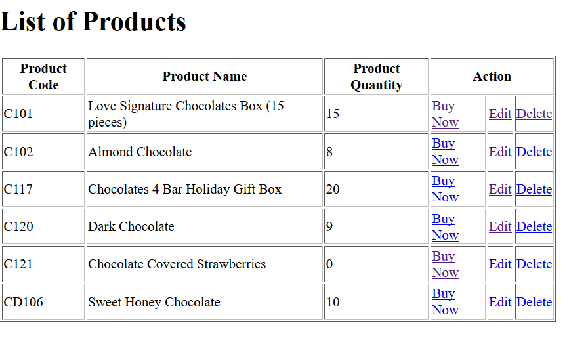

* If the **Edit** link is clicked, redirect the user to the **edit.php** file and display the chosen product’s details as shown below.

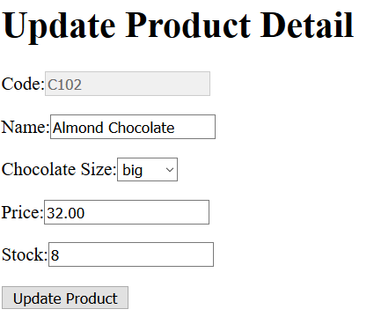

* When the **Update Product** button is clicked, the chosen product will be updated with the new data. The product code cannot be updated.
* Next redirect the user back to the **product_list.php** page.
* If the **Delete** link is clicked, show a JavaScript confirm pop-up box to the user.
* If the user clicks OK, delete the chosen record. Do not completely delete the record from the table. Set the **product_isDelete** attribute to 1. This means that the record will still be in the table but will not be displayed to the customer.

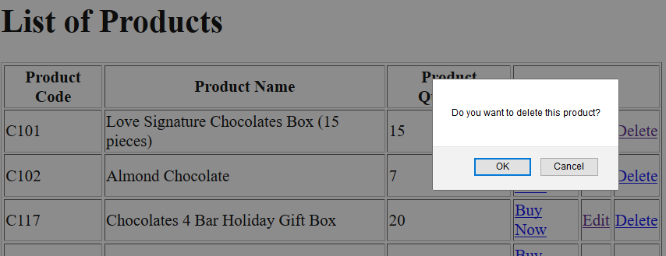

The product table(product_isDelete is set to 1 for Love Signature):

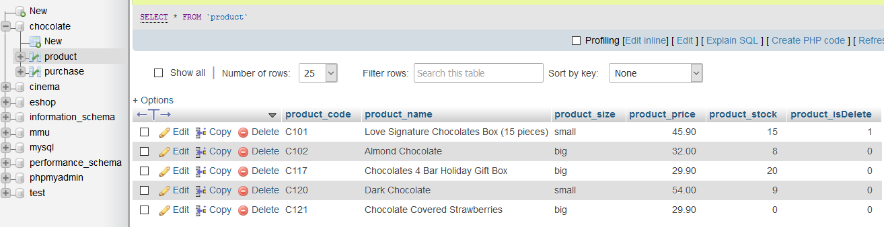

* If the **Buy Now** link is clicked, redirect the user to the **purchase.php** page. Pass the chosen product code to this page.
* In the **purchase.php** page:
  + Display the product details on the top.
  + At the bottom show a form for the user to enter their name and quantity required.
* Make sure the **quantity** required is lesser than the stock level.
* Insert the new purchase record into the **purchase table**.
* **Update the latest balance** for the product in the **product table**.

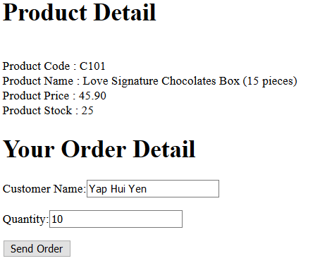

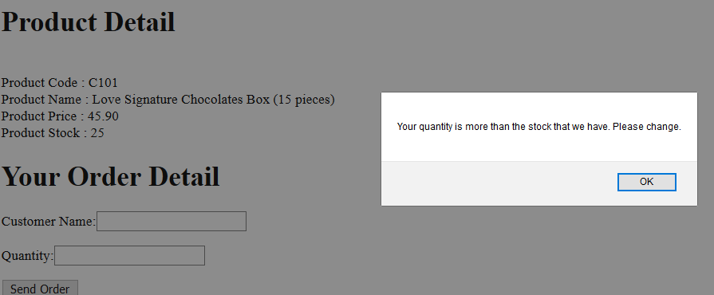

1. **View all orders**

* Open the **order_details.php** file in Notepad++.
* Write the PHP codes to display the orders made by customers as shown below.
* Create a button called “View Order” in **add_product.php.** Connect it with **order_details.php** file.

